**Lecture 19: Development System**

10801040 莊博恩、10801128 陳俊鴻

1. Lecture Notes

(1) 受精卵分化為三個胚層和生殖細胞：細胞分化機制就像為一群myoblasts中有master switch gene(作為開關)，控制muscle differention。

(2) hourglass model：演化有特定藍圖，而在藍圖中有特定階段可以讓modification產生，分別為：早期(演化上所有新的嘗試)與晚期(適應環境的選擇)，而中期的藍圖幾乎固定。

(3) 所有演化差異的改變都是發生在germline；透過轉植胚胎的實驗得知，胚胎細胞做為organizer (分泌morphogen，使細胞分化為為特定結構)

(4) 先有determination，才有differention，細胞先透過接受不同signal，決定將要分化成哪種特定細胞，再開始進行分化，而基因的表現調控此分化，不同組合的基因表現可以形成不同組合的signal，同一個fibroblast接收不同訊號(morphogen)後可以發展成為不同細胞。

(5)受精卵如何決定頭和尾等身體結構的位置？(germ cell位於頭，因此也決定了germ cell和somatic cell的位置)

xenopus的卵中，精子進入的位置會釋放訊號，使cortex開始轉動，也牽動本來就固定在cortex上Wnt 11開始旋轉，最後使的位於對邊的 Wnt 11決定身體的頭部的位置；果蠅藉由biocoid等蛋白質的gradient決定頭尾及節肢等結構的位置，其中有不同基因參與決定(posterior和anterior system決定頭尾，terminal和dorsoventral system決定外胚層、內胚層、中胚層)

2. Assigned Question and Answer

受精卵分裂成兩個之後，兩個子細胞有沒有完全一樣？

我仔細想了這個題目，列出了兩種可能假設

1. 兩個細胞不一樣，儘管也許基因相同，但彼此表現出的RNA與蛋白質的種類及數量卻不盡相同，故彼此在功能上會有差異，往後在分化成四個細胞、八個細胞時可能繼續產生更多有差異的子細胞，進而透過morphogen的方式形成外胚層、中胚層與內胚層，最後形成完整個體
2. 兩個細胞完全相同，在不斷分化成八個細胞、十六個細胞後才開始產生差異，例如從十六個細胞形成的複合體來說，有些細胞位於複合體內部，和外界沒有接觸，有些細胞位於複合體表面，部分細胞表面外界接觸，這個差異很可能就會導致往後細胞產生功能上的分化(例如，細胞會透過彼此接觸傳遞signal，且接觸面越大，收到的signal也越多，因此外部和內部細胞收到的signal的量就會不同，並在未來根據signal的不同分化成不同細胞)

因此我沒辦法很確定兩個子細胞是否會完全一樣，我認為可以先從驗證上述提到的假設去判斷—兩個細胞表現出的RNA和蛋白質種類或數量有沒有一樣？

***Retrospective analysis: reproducibility of interblastomere differences of mRNA expression in 2-cell stage mouse embryos is remarkably poor due to combinatorial mechanisms of blastomere diversification [1]***

我在這篇論文中查到了在一對sister blastomeres中兩個細胞所表現出某些基因的RNA數量的確是不一樣的，在論文中一共使用了有43 對sister blastomeres，包含五種不同datasets，分別為GSE21688, GSE22182, GSE45719, E-MTAB-3321, GSE94050，並找出這些不同轉錄組的共同基因，最後找到了10050個共同基因。(Figure A)

接著再比較這五種不同轉錄組內哪些基因在sister blastomeres中的RNA表現量不同，某一基因在某一組dataset中基因表現量在sister blastomeres中不同的標準定義為：

1. 此基因在同一對sister blastomeres中基因表現差異必須>2-fold intra-pair ratio
2. 在同一組dataset中符合(1)的sister blastomeres對數需大於該datasets的總sister blastomeres數的一半。

用上面的篩選標準，將10050個共同基因中在sister blastomeres的表現量差異的圖如下，可以發現一共有五種基因在五個datasets中sister blastomeres的表現量差異皆符合上述兩個標準。(Figure B)

We used a Venn diagram tool to identify genes that are consistently differently expressed between sister blastomeres across studies (consisting of 43 blastomere pairs in total). Because the transcriptomic depths of the datasets are different, it follows that there is a bias in the size of the intersections between the differently expressed genes of the ﬁve studies. To address this, the total gene lists of each dataset were uploaded to the InteractiVenn (Heberle et al., 2015) application, yielding Venn diagrams in Edwards layout (Fig. 2). The Venn diagram intersection of the ﬁve transcriptomes resulted in asset of 10050mRNAs (Fig.2A). We used this common set of genes to interrogate each study for the mRNAs that present >2-fold intra-pair difference observed in ≥50% of the blastomere pairs (Fig. 2B). This analysis returned ﬁve genes that are shared by all ﬁve studies (1700010D01Rik, Fstl5, Pnrc2, Zfp472 and Tead1; Supplementary Table 1).

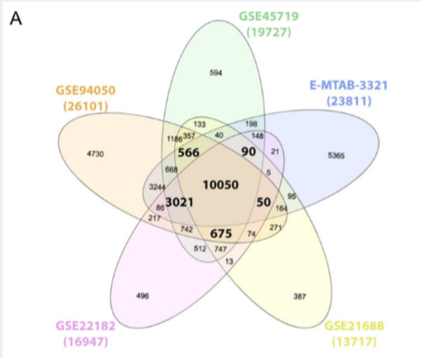

▲Figure A

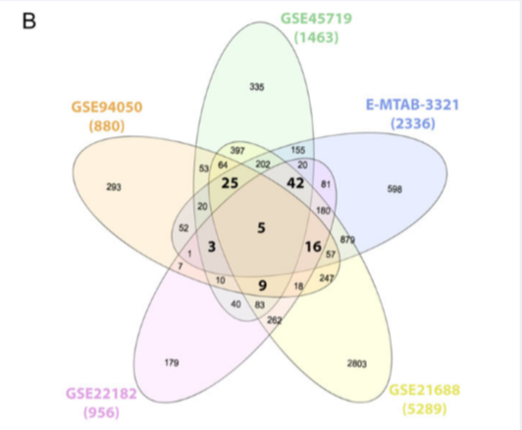

▲Figure B

最後再取這5個基因和另外其他95個基因(在五個datasets中有四個datasets不同，一個相同)，共100個基因去進行下述關於機制的探討。

為何標準要訂定成這樣？

在標準(1)中，>2-fold intra-pair ratio可以確保兩個sister blastomeres中RNA表現量確實是有差異的，可以避免因為測量誤差(capturing noise)而造成誤判的情況。

而標準(2)是確保表現量不同的sister blastomeres對數在該datasets中佔有至少一半的比例，這樣才有足夠的理由說明此datasets中該基因在sister blastomeres的表現量是有差異的。

We defined an arbitrary but robust double cut-off criterion to make the call of ‘different’ gene expression between sister blastomeres, namely: >2-fold intra-pair ratio (cut-off 1) observed in ≥50% of the blastomere pairs (cut-off 2). A 2-fold ratio is used as the threshold because it has been shown that mRNAs with ratios up to 1.5 were more frequent in technical replicates than in biological replicates ([Shi et al., 2015](javascript:;)), so that, after adding a security margin, we suggest that differences of more than 2-fold are no longer capturing noise. A 50% cut-off for the blastomere pairs was chosen because each study contains multiple pairs, and we reasoned that the interblastomere difference should be observed in most of them to qualify as conspicuous.

這樣的做法可以增加實驗的準確性，也可以避免取到一些在兩個sister blastomeres中預測表現量會相同的基因，例如housekeeping genes應該在兩個細胞中都會表現，表現量可能也不會有太大差異(推測)，這些基因可以用此方法篩選掉，留下我們想要觀察的表現量不同的基因。

從上述，可以得知基因的RNA表現量在sister blastomeres中是有差異的，因此應該可以證實我提出的第二個假設是錯的，兩個細胞的確不一樣，然而，又是什麼機制讓這些RNA的表現量不同？

在四篇論文中，提到了四個假設：

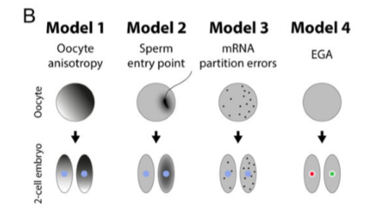

1. 平常分子在細胞內即存在特定的不均勻分布(在細胞的某一處或某一極濃度比較高)，而在細胞分裂的時候也具有特定的切割方向(例如along the animal-vegetal axis(meridian與equatorial))，當切割方向把不均勻分布的濃度切成濃度高與濃度低兩區，就會導致產生的子細胞所含該物質的濃度不同。

(註：附錄的論文寫第一次分裂(meridian切位)會產生相同的兩個子細胞，第二次分裂(equatorial切位)才會產生不同的兩個子細胞，和本篇觀點衝突，我認為作者這裡應該只是想要引述此分裂造成子細胞濃度不同的機制)

That could be explained by the finding that the orientation of the first cleavage is generally thought to be meridian, along the animal-vegetal axis, with the animal pole marked by the second polar body [33]. A result of that is transcriptome asymmetry within blastomeres but not between the first embryonic sister blastomeres, both showing the same gradient similar to that of the former zygote [11]. In line with that, it has been demonstrated that developmental bias depends on the pattern of the second equatorial cleavage divisions [34], resulting in molecular heterogeneities between blastomeres, evident as early as the 4- and 8-cell stages. [2]

1. preferential distribution of sperm-associated material

觀察但的單性生殖胚胎，發現若有精子進入，觀察的到兩個子細胞有不同的cell fate(分別形成embryonic和abembryonic parts)，若沒有精子進入，受精卵分裂出的兩個子細胞無法展現不同的cell fate。另外，精子進入後會產生fertilisation cone，且fertilisation cone的位置可以決定受精卵的一次分裂的plane，若把精子進入位置的cortical cytoplasm移除，受精卵首次分裂將無法形成embryonic和abembryonic parts。可以推測精子進入後可能會使某些分子在受精卵的某一極分布比較集中，因此分裂後才能產生不同的cell fate，若把精子的進入位置移除掉，受精卵進行分裂時可能就沒辦法把這些集中的分子剛好切到同一個子細胞內，子細胞也就無法形成embryonic和abembryonic parts

The ﬁrst cleavage of the fertilised mouse egg divides the zygote into two cells that have a tendency to follow distinguishable fates. One divides ﬁrst and contributes its progeny predominantly to the embryonic part of the blastocyst, while the other, later dividing cell, contributes mainly to the abembryonic part. In contrast to fertilised eggs, we found there is no tendency for the ﬁrst two parthenogenetic blastomeres to follow different fates. When the cortical cytoplasm at the site of sperm entry is removed, the ﬁrst cleavage plane no longer tends to divide the embryo into embryonic and abembryonic parts.

[3]

1. 平常分子是呈現「均勻的」「機率」分布，但在隨機的細胞分裂時時候因為是機率，難免造成一邊子細胞比較多、一邊子細胞比較少，此微量的影響有可能會在未來第二次、第三次分裂時擴大或縮小，然而當擴大到一定程度時，會給細胞一個訊號(transcriptional clue to guide future cell fates)，進而決定此細胞的cell fate，使細胞分化成不同型態或功能的特定細胞

We show that random segregation at the first cleavage division, known as ‘partitioning errors’, provides an important source of initial blastomere-to-blastomere heterogeneity. During the two- to 16-cell stages, zygotic transcriptional activation generates different molecular feedbacks that minimize or enhance the initial blastomere-to-blastomere biases, resulting in different gene clusters with either a ‘monostable’ (ubiquitous expression between blastomeres) or ‘bistable’ (strongly asymmetric expression between blastomeres) pattern. For those genes with a bistable pattern, the relative ratio of opposing lineage specifiers in each blastomere creates an inclined ‘lineage strength’, providing a transcriptional clue to guide future cell fates ahead of morphological distinction.[4]

1. asynchronous embryonic genome activation (EGA) between the sister blastomeres

EGA(embryonic genome activation)就是指在卵母細胞觀察不到，但在卵母細胞分裂出來的其中一個子細胞觀察的到的RNA(只能在其中一個子細胞觀察到，另一個沒有)，就好像胚胎的genome突然被活化一樣，目前認為可能和TFs與epigenetic modifiers的調控有關

Fifteen percent of the mRNAs with large SSwe (SSwe > 4 × SSbe) were not detectable in mature oocytes ([Ramskold et al. 2012](https://www.ncbi.nlm.nih.gov/pmc/articles/PMC4216920/" \l "B36); [Xue et al. 2013](https://www.ncbi.nlm.nih.gov/pmc/articles/PMC4216920/#B51)), and thus belonged to EGA transcripts. A subset of 2-cell bimodal genes was transcribed by the embryo genome in one and only one blastomere in 2-cell embryos ([Fig. 5A](https://www.ncbi.nlm.nih.gov/pmc/articles/PMC4216920/figure/F5/); Supplemental Fig. S5A). This reproducible pattern cannot be explained by transcription noise alone. It is tempting to hypothesize that WNT-related TFs and epigenetic modifiers (Supplemental Tables S4–S7) regulate blastomere-specific EGA.[5]

另外，論文也提到使用上述100個基因去判斷分別是屬於哪個model時，有65個基因不屬於四個model的任何一個，因此極可能還有的五種以上的model尚未被發現

那這時的第三個問題是：

這些基因RNA表現量不同會造成甚麼影響？為什麼在sister blastomeres中的表現量要有差異(為什麼基因表現不要都相同就好)？

在剛才提到的100個基因中，其中有四個基因比較特別：Eomes, Tead1, Phlda2 and Cops3(和cell lineage speciﬁcation或proliferation有關)

Eomes：required for mouse trophoblast development and mesoderm formation

Tead1：expressed in both mouse trophectoderm and inner cell mass, where it interacts with Yap, suggesting common roles in Hippo signalling

Phlda2：expressed in mouse trophectoderm and extraembryonic ectoderm, where it modulates placental growth

Cops3：crucial for the maintenance of cell proliferation in the mouse epiblast, which was the main contributor to the phenotypic discordance of monozygotic twin blastocysts

It is therefore tempting to envision that the interblastomere differences (whatever the cause) might inﬂuence the fate of daughter cells at the blastocyst stage

因此可以推測，因為受精卵分裂出的這兩個blastomere表現的mRNA的量有差異，且此mRNA表現的量應可以遺傳給下一個子代(四細胞、八細胞期)，故未來這兩個blastomere很可能各自分化成「不同功能」甚至「胚胎的不同區域」，舉例來說，Eomes具有mesoderm formation的能力，很可能擁有較多Eomes mRNA的blastomere就會分化成mesoderm(因為基因表現程度大，轉譯出的蛋白較多)，這樣子的解釋也可以由目前已知的一個觀察驗證---sister blastomeres其中一個會分化成blastocyst的embryonic part，另一個會分化成abembryonic part，在blastocyst負責不同功能---而正是因這兩個blastomere在某些基因分別表現不同的mRNA量，因此最後才形成了具有不同功能的embryonic與abembryonic part，這應該就是為什麼在sister blastomeres中的基因表現量要有差異。

The first evidence leading to this view was the finding that the orientation of the first cleavage division along the AV axis tends to be perpendicular to the embryonic-abembryonic axis of the future embryo.

Consequently, in most embryos, descendants of 2-cell blastomeres contribute more cells to either the embryonic or abembryonic parts of the blastocyst.

It was also proposed that, in most mouse embryos, the point where the sperm originally entered the oocyte marked the blastomere that cleaved faster and contributed preferentially to the embryonic part (ICM) and, *vice versa*, progenies of the other unmarked blastomere contribute predominantly to the abembryonic pole

最後，我推測既然最後能形成不同種類的細胞，那是不是除了mRNA的量以外，很可能這兩個blastomere在其他方面也有差異？

經過查詢，我的確查到了除了mRNA的量以外，兩個blastomere的體積大小也不同，同時在各自blastomere內的mitochondria DNA copies的數量也不同，這些不同都很有可能是造成sister blastomeres具有不同cell fate的原因

The cytoplasm of the oocyte, for example, does not divide equally into daughter blastomeres after the first cleavage, with up to a 10% difference in volume between the smallest and the largest blastomere[22](https://www.nature.com/articles/s41598-017-08266-6#ref-CR22)

These differences of blastomere size correlate positively with the number of DNA copies present in mitochondria[22](https://www.nature.com/articles/s41598-017-08266-6#ref-CR22), whose unequal segregation might be implicated in the fate of blastomeres. Thus, we kept track of the size of the sister blastomeres, selecting and scoring an additional series of MZ twins in which the initial blastomeres differed in size by more than 5%. However, the blastocyst imbalance (30/70%) was still observed. [6]

最後，出於好奇，因為在上述解題的過程中我發現了另一個理論(第一次分裂時產生的兩個cell一樣，第二次分裂時產生的cell才不一樣，和我的假設(2)似乎有點像)，於是我去查詢了另一個理論的機制。

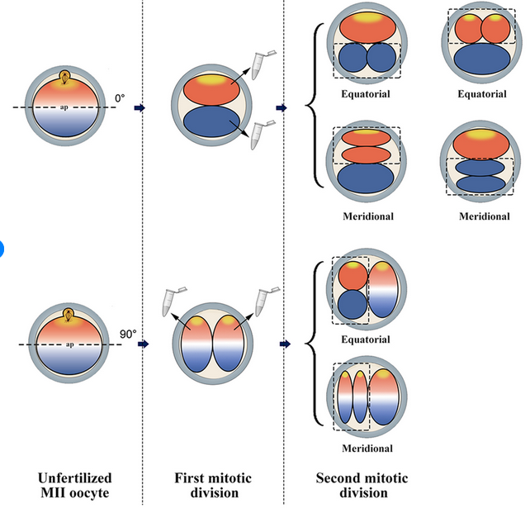

The importance of orientation of the embryonic divisions. Cleavage can occur either equatorially or meridionally, along the animal-vegetal axis, with reference to MII-spindle as the hypothetical animal pole. A result of equatorial first cleavage division is the transcriptome asymmetry between the balstomeres of 2-cell embryo that could persist even after the second cleavage division. By contrast, a result of meridional first cleavage division is the transcriptome symmetry between the balstomeres of 2-cell and 3-cells embryos, despite oocyte transcript polarity. Moreover, indiscriminate separation of 2-cell embryos yields constraints that exclude the possibility that transcriptome asymmetry within MII-oocyte leads to programmed asymmetric transcriptome inheritance between blastomeres of 2-cell embryos. [7]

和上述的第一個model很像，判斷依據在embryonic divisions的orientation，平時細胞內即具有不均勻的分子分布，若細胞分裂時剛好把不均勻的地方分開(切割方向和不均勻的方向垂直)，會形成不同的子細胞(asymmetry)，若切割方向剛好和不均勻的方向平行，即會形成相同的子細胞(symmetry)。然而，根據上述許多觀察發現，不管是mRNA的量、細胞大小，或是mitochondria DNA copies的數目在two-cell時期時的sister blastomeres間即有差異，故我認為應該是上面(紅色圈)那個model (asymmetry)才是正確的。

Reference

[1] E Casser, S Israel, S Schlatt, V Nordhoff, M Boiani. (2018). Retrospective analysis: reproducibility of interblastomere differences of mRNA expression in 2-cell stage mouse embryos is remarkably poor due to combinatorial mechanisms of blastomere diversification. Molecular Human Reproduction. *24*(7). 388–400.

<https://doi.org/10.1093/molehr/gay021>

[2]Eva Held, Dessie Salilew-Wondim, Matthias Linke, Ulrich Zechner, Franca Rings, Dawit Tesfaye, Karl Schellander, Michael Hoelker. (2012). Transcriptome Fingerprint of Bovine 2-Cell Stage Blastomeres Is Directly Correlated with the Individual Developmental Competence of the Corresponding Sister Blastomere. Biology of Reproduction. *87*(6). 154, 1–13. <https://doi.org/10.1095/biolreprod.112.102921>

[3] Piotrowska K, Zernicka-Goetz M. (2002). Early patterning of the mouse embryo--contributions of sperm and egg. *Development*. *129*(24). 5803‐5813. doi:10.1242/dev.00170

[4] Shi J, Chen Q, Li X, *et al*. (2015). Dynamic transcriptional symmetry-breaking in pre-implantation mammalian embryo development revealed by single-cell RNA-seq. *Development*. *142*(20). 3468‐3477. doi:10.1242/dev.123950

[5] Biase, F. H., Cao, X., & Zhong, S. (2014). Cell fate inclination within 2-cell and 4-cell mouse embryos revealed by single-cell RNA sequencing. *Genome research*, *24*(11), 1787–1796.

<https://doi.org/10.1101/gr.177725.114>

[6] Casser, E., Israel, S., Witten, A., Schulte, K., Schlatt, S., Nordhoff, V., & Boiani, M. (2017). Totipotency segregates between the sister blastomeres of two-cell stage mouse embryos. *Scientific reports*. *7*(1). 8299. <https://doi.org/10.1038/s41598-017-08266-6>

[7] <https://www.researchgate.net/figure/The-importance-of-orientation-of-the-embryonic-divisions-Cleavage-can-occur-either_fig7_299539575>